Given API is a simple example to read and access database connection.

Use any API testing tools. (Like Postman, Rested etc. either web or application)

Following are the process to test given APIs:

1. [**http://localhost:1000/create_user**](http://localhost:1000/create_user)
2. API Type : POST
3. This URL is used to create a new user in system.
4. You need to pass information as following screenshot
5. Headers must be as below:
   1. Authorization -> Bearer testtoken
   2. Content-Type -> application/x-www-form-urlencoded
   3. If you will select Type as URLEncoded form data then it will automatically select point 6 Content-Type .
6. Body Content for user is as below (You can pass any value for these body contents):
   1. firstName -> ‘Mac’
   2. lastName -> ‘Mohan’
   3. userAddress -> ‘New York’
7. 200 status for successfully inserted data otherwise you will get error message.
8. 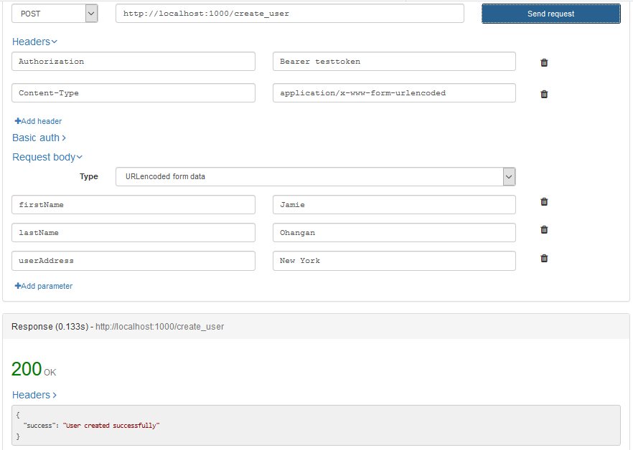
9. **http://localhost:1000/get_user/userID**
10. API Type: GET
11. This URL is used to get one user information by user id.
12. You need to pass information as following screenshot
13. In screenshot 1 (**userID**) is id of user mentioned in URL
14. Headers must be as below:
    1. Authorization -> Bearer testtoken
15. If user exists in database then you will get information otherwise it will give you blank information with 200 status (If successful).
16. Please see screenshot for more information.
17. 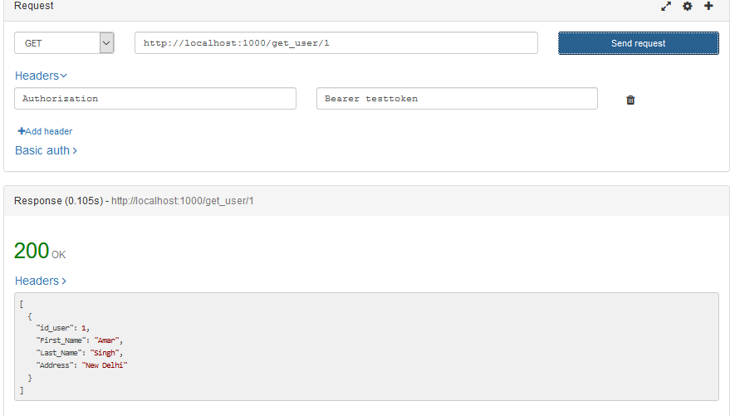
18. [**http://localhost:1000/get_users**](http://localhost:1000/get_users)
19. API Type: GET
20. This URL is used to get all user list in database.
21. You need to pass information as following screenshot
22. If user will existing in database then you will get information otherwise it will give you blank information with 200 status (If successful).
23. Headers must be as below:
    1. Authorization -> Bearer testtoken
24. Please see screenshot for more information.
25. 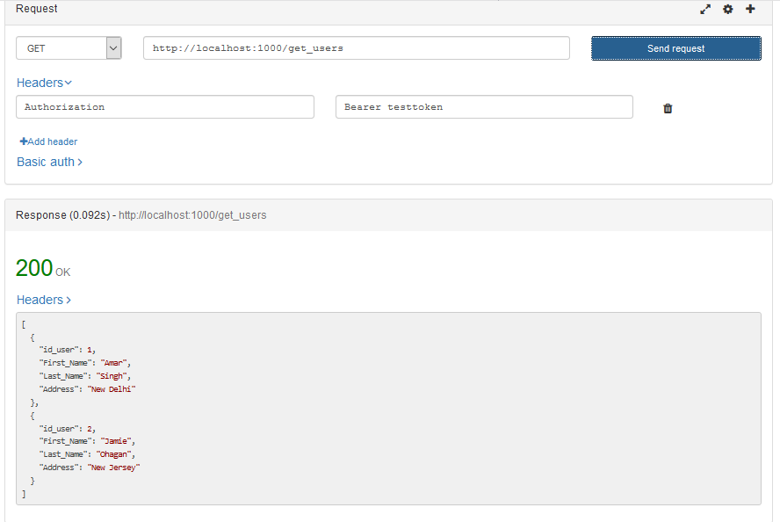

Following are some database related queries.

create database UserDb;

Use UserDb;

Create Table Users

(

id_user INT AUTO_INCREMENT,

First_Name VARCHAR(2000),

Last_Name VARCHAR(2000),

Address VARCHAR(2000),

PRIMARY KEY (id_user)

);

INSERT INTO Users (first_name, last_name, address) VALUES ('Amit', 'Singh', 'Delhi')

SELECT * FROM Users